How lucky I was to know what I wanted to be from the very early age. An architect friend of my father’s arranged for me to go to Sydney to work with a firm of architects Hennessy Hennessy and co-in Martin Place Sydney just after my graduation at the end of 1948. A doctor friend of mine who graduated also in 1948 married an American girl and at their reception she said to me “now that you have your bachelor degree why don’t you apply for a graduate scholarship at one of the six Ivy League universities in America, as all of them have lots of scholarships for foreign students” and she gave me the names of Yale, Harvard, Columbia, Princeton and Pennsylvania. I also met Glen Radford, a lad from Sydney, who when he heard that I was going to live in Sydney invited me to come and meet his family who lived in Point Piper. Both these contacts changed my direction in life. Sheer luck.
When settled in Sydney I contacted the Ivy league universities in America applying for a graduate scholarship in architecture. They all offered me a scholarship but Pennsylvania was the only one that offered it in that year of 1950. The only real problem was that I had no way of paying the fare to get there. I had established a true friendship with the Radford family and Mr Fred Radford told me that United States had just started a new program called the Fulbright which paid for the costs of travelling from Australia to an American university and back again. I successfully applied for the Fulbright and six of us from New South Wales, one from each discipline such as engineering, architecture, medicine, philosophy and so on were promised reimbursement of our first class travel to our universities in America. Mr. Radford paid for the outgoing trip which I reimbursed as soon as the money was paid by Fulbright into my account. As a matter of interest the following year they sent 22 Fulbrights economy class.
When I returned to Sydney early in 1952 I worked for a short time with Fowell Mansfield and Maclurcan. The Fulbright chairman, Mr. Hauslaub, who was also the CEO of Ford Australia had a son-in-law Bob Audette, had just bought a block of land in Castlecrag and was looking for an architect. Mr Hauslaub told him that a young architect had just returned from America as a Fulbright scholar and that is how I was contacted to design the Audette house. The Radford family was also responsible for me meeting my fiancé Rosemary Patrick and it was one of her mother’s relatives who offered me late in 1952 to design and build the Winn’s department store in Fairfield. With those two projects I started my own practice. Talk about luck!

The important thing is to understand who you are and to trust your natural instincts.
We all appreciate art differently to one another, whether it is architecture or music or any other form of art. And so it is with the creative process of design. I personally think that architecture and music have a lot in common. From a very early age I was instinctively passionate about the compositions of Johan Sebastien Bach and this kind of music starts with a particular theme and by developing variations on this theme a musical story unfolds. I instinctively and intuitively approached architectural design in a similar way. Intuitively a theme was established by close observation of the site and the client’s needs then by quiet contemplation a three-dimensional image emerges with theme variations to produce the prototype image. This is design by the heart and then the mind takes over to organise the practical and physical issues in accordance with ones training. I eventually called this intuitive approach site-specific.
Your natural instincts are established at a very early age and develop and mature according to your environment and upbringing.

My mother said that from the age of three when I was asked what I wanted to do when I grew up, I replied I wanted to be an artichoke. This desire to be an architect never varied. I think I was extremely fortunate to be born in Adelaide spending so much time exploring the surrounding bushland and developing a love of nature. Also at that time in the 19 40s there was no architectural faculty at the University of Adelaide. To become an architect, you had to enrolled at the South Australian School of Mines and Industries in a 5 to 7 year course. We were required to enroll as apprentices in the full programs for plumbers, carpenters, bricklayers and surveyors.
Our architectural lecturers were not professional teachers, but architects who ran their own successful practices in Adelaide volunteering their time. No fixed architectural philosophy or concept was taught. The approach to teaching architectural design was to set a design problem which each individual had to solve in his own way. The results were then individually examined for problems of practical application and the individual design solutions were not criticised according to the personal aesthetic approach of the judging architects. Respect for architectural history was taught as something to be observed not copied.
I was aware most students normally developed a two-dimensional plan from which they projected elevations to complete their designs, solutions usually found by research into architectural magazines and so on.
I had no conscious path as to how I would approach my future designs. Never having bought architectural magazines or books on architecture, (those that I do have were given by friends, clients and architects who thought I might be interested) I think my particular approach was intuitive due to the fact that I spent so much of my time as a young person in the Australian bushland.

An artist who is pressured to explain the meaning of his work tends to develop an intellectual interpretation rather than one from the heart. The work itself is the true and complete explanation.
Those architects who instinctively love to use natural materials and respect nature are classified by academics and journalists as organic architects. However, real organic architecture, universally, is constructed entirely out of local materials and more importantly that the form of the buildings nearly always conforms to symbolic references which add another dimension of meaning and significance.

Architectural photographs have a certain role to play in as much as they identify a building, make archival records of the finer details and indicate the colours and various materials employed. They can also restore memory of those whole have visited the site.
However, photographs give no sense of scale or space or perspective or texture which can only be experienced by physical presence. As an example, in 1996 I had a very large project for Canyon Ranch, the largest wellness spa company in the world and they invited me to inspect their major facility in Tuscon Texas. As it happened it was very close to Wright’s Talieson West and my only knowledge of that was by photographs so I drove over to make a physical inspection. I got the shock of my life. It was completely alien, very small in scale and so obviously a tent complex. So now, seeing the photos I do understand the reality.
I have to say that photographs of my work are pretty well all that remains as proof of their previous existence. That includes most of my domestic and commercial projects. My three resort hotels in Indonesia are still fully intact however.
The few of my Australian buildings that remain have been so dramatically modified and extended to be unrecognisable.
I am not particularly concerned about this as each project was for a specific person or family and when they moved on the new owners acquired the property not for the modest house but because of its location. As an example, in 1959 I designed a house for Hugh and Anne Hamilton on a magnificent wooded north facing 2 acre site overlooking Pittwater from the heights of Bayview. Nearly 50 years later
she sold the property because of her age and sent me this note below which I appreciate and value more than the house itself …. “mission accomplished”.
The new owner payed over 3 million dollars then demolished the house to build his macmansion.
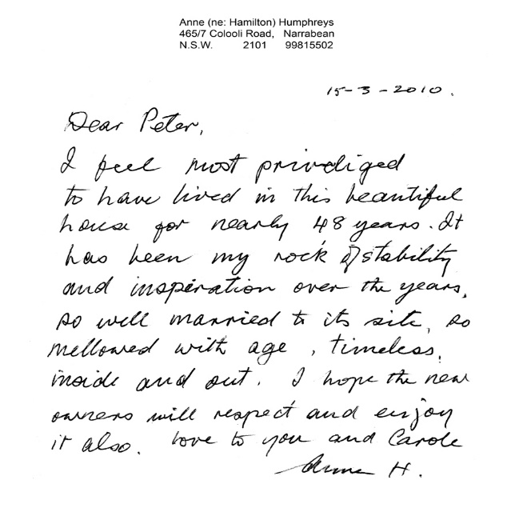

This was my intended order of photo presentation:

View Threeexamples as examples of what others have done to three of my houses.
First house Audette 1952
First commercial Winns Department store 1953
Second house for Peter Muller 1953
Third house for Victa Richardson 1955
Third commercial Victa mowers HO 1958
Fifth house McGrath 1957
Fifth commercial Hoyts Newcastle 1959
Sixth house Nicholson 1957
Seventh house Walker 1958
Sixth Commercial Rockdale Plaza 1961
Seventh commercial IPEC HO 1961
Tenth house Richardson Ski Lodge 1958

Sixteenth house Hamilton 1962
Seventh commercial Dixon Hotel/Motel 1964
Tenth commercial Hoyts Drive-ins 1966
Eleventh commercial Hoyts Cinema Centre 1966-69
Fortieth and last house Williams 1987
Thirty fifth and last commercial Oberoi Lombok 1997
Twenty International projects, other houses and commercial work not listed above can be viewed on this website.

